WEEK 1 HANDS_ON
ALGORITHMS_DATA STRUCTURES
Exercise 2: E-commerce Platform Search Function
package Data_structures_and_algorithms;
class Product {
int productId;
String productName;
String category;

Product(int id, String name, String cat) {
productId = id;
productName = name;
category = cat;
}
}

public class EcommerceSearch {

static Product linearSearch(Product[] arr, String key) {
for (Product p : arr) {
if (p.productName.equalsIgnoreCase(key))
return p;
}
return null;
}

static Product binarySearch(Product[] arr, String key) {
int low = 0, high = arr.length - 1;

while (low <= high) {
int mid = (low + high) / 2;

int cmp = arr[mid].productName.compareToIgnoreCase(key);

if (cmp == 0) return arr[mid];
else if (cmp < 0) low = mid + 1;
else high = mid - 1;
}
return null;
}

public static void main(String[] args) {

// IMPORTANT: Sorted for binary search
Product[] products = {
new Product(105, "Bag", "Fashion"),
new Product(101, "Laptop", "Electronics"),
new Product(102, "Mobile", "Electronics"),
new Product(103, "Shoes", "Fashion"),
new Product(104, "Watch", "Accessories")
};

Product result1 = linearSearch(products, "Watch");
Product result2 = binarySearch(products, "Watch");

System.out.println("Linear Search: " + (result1 != null ? "Found" : "Not Found"));
System.out.println("Binary Search: " + (result2 != null ? "Found" : "Not Found"));
System.out.println("Best Case: O(1)");
System.out.println("Average Case: O(n)");
System.out.println("Binary Search Case: O(log n)");
}
}
OUTPUT:
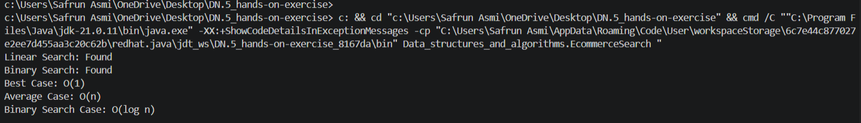

Exercise 7: Financial Forecasting
package Data_structures_and_algorithms;
public class FinancialForecast {

// Recursive method to calculate future value
static double forecast(double currentValue, double growthRate, int years) {
if (years == 0) {
return currentValue;
}

return forecast(currentValue * (1 + growthRate), growthRate, years - 1);
}

public static void main(String[] args) {

double initialValue = 1000; // starting amount
double growthRate = 0.10; // 10% growth
int years = 5;

double result = forecast(initialValue, growthRate, years);

System.out.println("Initial Value: " + initialValue);
System.out.println("Growth Rate: " + (growthRate * 100) + "%");
System.out.println("Years: " + years);
System.out.println("Predicted Future Value: " + result);
System.out.println("Calculation Method: Recursion");
}
}
OUTPUT:
